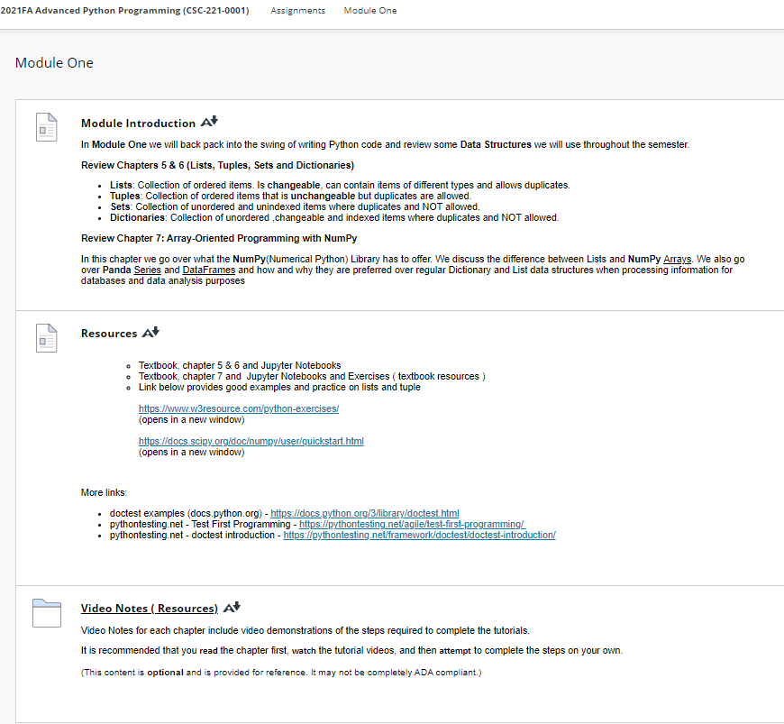

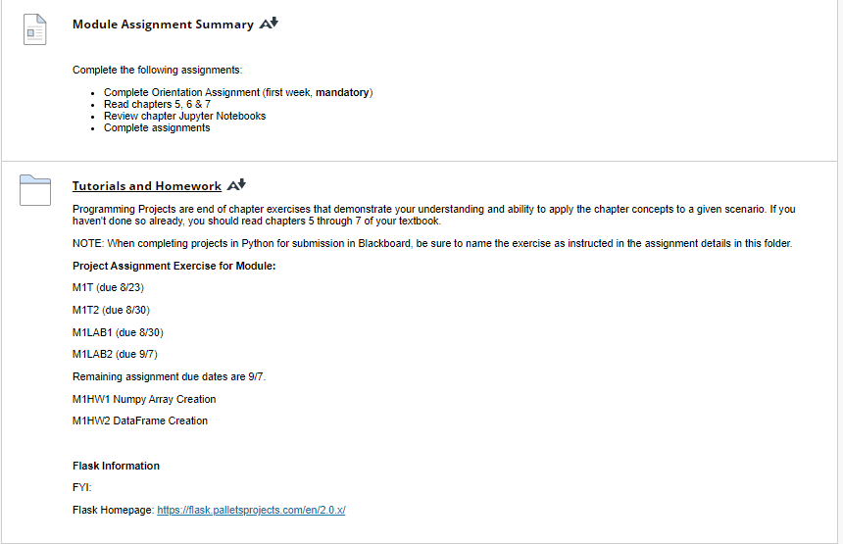

**Resources**

[Resources](https://faytechcc.blackboard.com/webapps/blackboard/content/listContent.jsp?course_id=_35059_1&content_id=_5950071_1)

* + Textbook, chapter 5 & 6 and Jupyter Notebooks
  + Textbook, chapter 7 and  Jupyter Notebooks and Exercises ( textbook resources )
  + Link below provides good examples and practice on lists and tuple  
    <https://www.w3resource.com/python-exercises/>(opens in a new window)  
    <https://docs.scipy.org/doc/numpy/user/quickstart.html>(opens in a new window)

More links:

* doctest examples (docs.python.org) - <https://docs.python.org/3/library/doctest.html>
* pythontesting.net - Test First Programming - [https://pythontesting.net/agile/test-first-programming/](https://pythontesting.net/agile/test-first-programming/%20)
* pythontesting.net - doctest introduction - <https://pythontesting.net/framework/doctest/doctest-introduction/>

### Video Note : Creating and Accessing Lists

<https://mediaplayer.pearsoncmg.com/assets/_lol_AxcAy0pMBRnLIqKhAPWL55y7oaj>

[Creating and Accessing Lists](https://mediaplayer.pearsoncmg.com/assets/_lol_AxcAy0pMBRnLIqKhAPWL55y7oaj)  
A video tutorial explains methods of  **Creating and Accessing Lists**  of *Deitel & Deitel , Intro to Python*.

(This video is **optional** and is provided for reference. It may not be completely ADA compliant.)

### Video Note : Creating and Accessing Tuples

https://mediaplayer.pearsoncmg.com/assets/gPVst43AxJG6rNCi1uYC2h7JefhXJrw4

[Creating and Accessing Tuples](https://mediaplayer.pearsoncmg.com/assets/gPVst43AxJG6rNCi1uYC2h7JefhXJrw4)  
A video tutorial **Creating and Accessing Tuples** of *Deitel & Deitel , Intro to Python* explains how to import modules, use functions and preview list of functions in a module.

(This video is **optional** and is provided for reference. It may not be completely ADA compliant.)

### Video Note : Creating and iterating through a dictionary

<https://mediaplayer.pearsoncmg.com/assets/B4lEheUs0CAKTf4Z1hzw2fo_oxb8Pbh0>

[Creating and Iterating through a Dictionay](https://mediaplayer.pearsoncmg.com/assets/B4lEheUs0CAKTf4Z1hzw2fo_oxb8Pbh0)  
A video tutorial explains methods of  **Creating and Iterating through a Dictionary**  of *Deitel & Deitel , Intro to Python*.

(This video is **optional** and is provided for reference. It may not be completely ADA compliant.)

### Video Note : Creating Sets

<https://mediaplayer.pearsoncmg.com/assets/Woq_C0yY2_gyVxC4VvroKKrpOQns7whh>

[Creating Sets and using Set Methods](https://mediaplayer.pearsoncmg.com/assets/Woq_C0yY2_gyVxC4VvroKKrpOQns7whh)  
A video tutorial **Creating Set and Using Set Methods** of *Deitel & Deitel , Intro to Python* explains how to import modules, use functions and preview list of functions in a module.

(This video is **optional** and is provided for reference. It may not be completely ADA compliant.)

### Video Note : Creating a NumPy Array from Existing Data

<https://mediaplayer.pearsoncmg.com/assets/3GENQr18r_PxK_VRy9iYga0t0R0Cb2gj>

A video tutorial explains methods of  **Creating a NumPy Array from Existing Data**  of *Deitel & Deitel , Intro to Python*.

(This video is **optional** and is provided for reference. It may not be completely ADA compliant.)

### Video Note : Creating DataFrames

<https://mediaplayer.pearsoncmg.com/assets/ko8OniGQjH9gUWt6zuzem3MZ2Rc_kIX9>

[Creating Panda DataFrames](https://mediaplayer.pearsoncmg.com/assets/ko8OniGQjH9gUWt6zuzem3MZ2Rc_kIX9)  
A video tutorial **Creating Panda DataFrames**of *Deitel & Deitel , Intro to Python* explains how to import modules, use functions and preview list of functions in a module.

(This video is **optional** and is provided for reference. It may not be completely ADA compliant.)

### [Tutorials and Homework](https://faytechcc.blackboard.com/webapps/blackboard/content/listContent.jsp?course_id=_35059_1&content_id=_5950076_1)

[Tutorials and Homework](https://faytechcc.blackboard.com/webapps/blackboard/content/listContent.jsp?course_id=_35059_1&content_id=_5950071_1)

Programming Projects are end of chapter exercises that demonstrate your understanding and ability to apply the chapter concepts to a given scenario. If you haven't done so already, you should read chapters 5 through 7 of your textbook.

NOTE: When completing projects in Python for submission in Blackboard, be sure to name the exercise as instructed in the assignment details in this folder.

**Project Assignment Exercise for Module:**

M1T (due 8/23)

M1T2 (due 8/30)

M1LAB1 (due 8/30)

M1LAB2 (due 9/7)

Remaining assignment due dates are 9/7.

M1HW1 Numpy Array Creation

M1HW2 DataFrame Creation

**Flask Information**

FYI:

Flask Homepage: <https://flask.palletsprojects.com/en/2.0.x/>